Year 13 NEA

To what extent is Mermaid Quay a Fortress Landscape?

Figure - Map of Mermaid Quay https://www.google.co.uk/maps/place/Mermaid+Quay,+Cardiff/@51.4635816,-3.1680653,534m/data=!3m2!1e3!4b1!4m5!3m4!1s0x486e0337c76d4031:0xf94e95c4c6431b7a!8m2!3d51.4635816!4d-3.1658766 (Accessed: 1st November 2022 10:11)

Joshua Netherton

Cleeve Sixth Form Centre of Excellence

Year 13 NEA

Contents

Introduction 2

Hypothesis 2

Specification Link 2

Theory and Research 2

Hypothesis Breakdown 6

1. Crime in Mermaid Quay occurs prevalently 6

2. Evidence of major fortification of Mermaid Quay is present. 6

3. Distribution of fortification is widely spread and even throughout Mermaid Quay. 7

Methodologies 8

Risk Assessment 9

Crime in Mermaid Quay occurs prevalently 9

Evidence of major fortification of Mermaid Quay is present 10

Distribution of fortification is widely spread and even throughout Mermaid Quay 12

Table of Figures 13

Bibliography 14

# Introduction

## Hypothesis

I have three hypotheses that will answer my main question. They are:

1. Crime in Mermaid Quay occurs prevalently.
2. Evidence of major fortification of Mermaid Quay is present.
3. Distribution of fortification is widely spread and even throughout Mermaid Quay.

## Specification Link

Throughout this document links will be made to the subject specification, which is AQA A-Level geography. The work I am doing will come from a certain section of the course I am studying and will typically link to more than once section. My investigation title is “To what extend is Mermaid Quay a fortress landscape?” This ties into primarily section 3.2.1.1 Globalisation and 3.2.3.2 Urban forms. Here we can investigate how Mermaid Quay is developed as a Fortress Landscape while serving its purpose as a shopping centre in the Cardiff Bay area.

My title links to multiple sections of the course. 3.2.1.1 is Globalisation and in a world ever expanding and growing, in terms of both population and security, fortress landscapes are both changing and growing ever more prevalent. Section 3.2.3.2 is Urban Forms, and different ways of fortifying links to this section. In Section 3.2.2.1 which is the nature and importance of place allows me to look at why somewhere like Mermaid Quay would be fortified.

Finally, the skills I will use to collect data links to Section 3.2.2.3, where I will use both numerical and worded sources of data to answer my sub-questions.

## Theory and Research

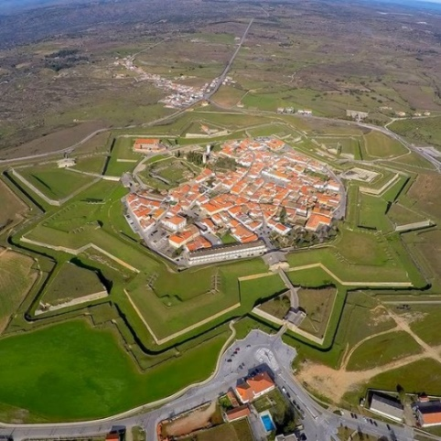Fortress Landscapes are deliberately landscaped and designed around security, protection, surveillance, and exclusion. [1] More prevalent in medieval era constructions you can visually see the defences in place, such as walls and moats, along with typical construction taking place at strategic high points with good visibility. These methods are done with the intent to provide the most security and safety to the inhabitants of the facility.

In the modern era it is less prevalent to see such blatant techniques, however, this isn’t to say methods aren’t still used that line up with the continued existence of fortress landscapes. Features such as CCTV (Closed Circuit Television), security alarms, gated communities, and speed bumps are all day-to-day features of towns and cities designed to protect and seclude residents.

Figure - Sky view of fortress https://www.atlasobscura.com/places/fortress-of-almeida (Accessed: 1st November 10:01)

One controversial fortress landscape more prevalent in modern day cities is anti-homelessness architecture. This is defensive architecture, hostile designs, or exclusionary designs [2] with the intention of preventing homeless people from residing in public spaces. There is a stigma of crime and unsafe behaviour surrounding homeless populations in cities and so city designers are including items such spikes, or contoured designs of benches to prevent the stay of homeless people. This will reduce the number of lingering people, but some see it as inhumane and cruel, considering how much they are already struggling, it 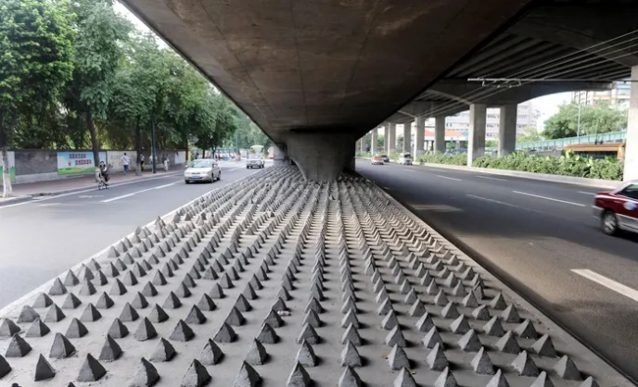isn’t fair to do this on top of that. Mosquito Alarms[3] provide a similar purpose by letting of a high-pitched squeal outside shops to disperse crowds and people are more on board with this, however, this is more designed for temporary crowds with somewhere to go. Anti-homeless architecture is designed to kick people out with nowhere else to go, hence its controversy.

Figure - Anti-homeless architecture https://www.theguardian.com/society/2015/feb/18/defensive-architecture-keeps-poverty-undeen-and-makes-us-more-hostile (Accessed: 3rd November 2022 10:52)

We can see another example of this in Figure 4, where the seating has been designed to prevent sleeping on by taking a curved design to resemble rocks. Whether this is intentional it is unclear, however, this design does result in no homeless people residing in this spot here in Mermaid Quay.

This is one of many features of a Fortress Landscape present in Mermaid Quay, and my research will investigate what else is present in this area to maintain safety and security. Designed as a seaside shopping spot in a once run-down area of Cardiff Bay. It has been significantly redeveloped and a large part of that – similar to many modern cities – has been ensuring safety and security is present and maintained but a larger part for Mermaid Quay has been ensuring that the look and feel of the area has not been tainted by features designed for this purpose. In Figure 3 the spikes could be considered an eye soar, not pleasant to look at and unfriendly for pedestrians passing by. Mermaid Quay’s approach is a much more appealing approach to preventing homeless people from sleeping in this area.

Figure - Anti-homeless architecture in Mermaid Quay Joshua Netherton (20th October 2022)

Figure - Highlight of Mermaid Quay https://www.google.co.uk/maps/place/Mermaid+Quay,+Cardiff/@51.4640905,-3.168601,16.11z/data=!4m5!3m4!1s0x486e0337c76d4031:0xf94e95c4c6431b7a!8m2!3d51.4635816!4d-3.1658766 (Accessed: 4th November 2022 11:04)

Figure - Map of Cardiff https://www.google.co.uk/maps/@51.4819126,-3.1767277,13z (Accessed: 4th November 2022 11:04)

Mermaid Quay is in Cardiff Bay, in the south of Cardiff City. It is based within the bay area, and by extension is protected by the Cardiff Bay Barrage. Accessible by both road and pedestrian only routes it is easy to access and get to for the majority of people and services.

 Cardiff is found on the South coast of Wales along the Bristol Channel. Once a major exporter of minerals such as coal and iron, following its deindustrialisation throughout 1971-2015 [4] this area is no longer used for industry like it used to be. For a time, Cardiff was a highly industrial export port for the Welsh mineral trade. However, as this industry declined so did the quality of the coastal area. For a time, the area behind the Cardiff Bay Barrage was mud and silt that smelt bad and made this an extremely unattractive place to be. Major regeneration took place in 2000 [5] and this worked on remaking an old dry dock and part of this was also the building of the modern-day Mermaid Bay.

Figure - Map of United Kingdom https://www.google.co.uk/maps/@54.4861569,-7.1862054,6z (Accessed: 4th November 2022 11:15)

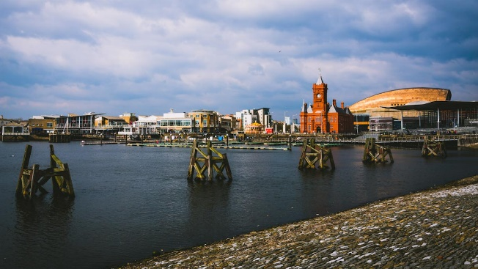Cardiff is located on the south coast of Wales, west of Newport and east of Swansea. It has a railway station, Cardiff Central, along with some of its own internal stations which allow for better connectivity throughout the city. The M4 and the A470 both run through Cardiff allowing for excellent connection with the rest of the country. This also means that nearby towns and villages are able to easily commute into the city. With its proximity to other cities and the ease of connectivity between them, this also permits excellent trade routes and connections between these cities promoting job opportunities and the further share of culture.

Figure - Place map for Cardiff https://www.google.co.uk/maps/place/Cardiff/@51.5517743,-3.7323955,9z/data=!4m5!3m4!1s0x486e02d434ec53f5:0x143406db6586670e!8m2!3d51.483707!4d-3.1680962 (Accessed: 4th November 2022 12:46)

As mentioned, Cardiff Bay has seen development throughout recent years. This development has been fuelled by local Urban Development Corporations. These are any several former organisations started by the government to develop and improve areas of the inner city. [6] In Cardiff, the Cardiff Bay Development Corporation (CBDC) formed on the 3rd of April 1987 has worked to improve this area. Covering an area of about 1,089 hectares. Mermaid Quay is a stronghold of shops and would’ve been one of the focuses of this redevelopment, as attracting tourists and businesses to an area is the best way to fuel the local economy and start a chain reaction of more money, more development, more money, and so on. This development corporation split Cardiff Bay into 9 sections, and Mermaid Quay would be in the inner harbour section. (Information taken from)[7]

Figure - Cardiff Bay https://walesguidebook.com/things-to-do/south-wales/cardiff/cardiff-bay/ (Accessed: 11th November 2022 11:50)

## Hypothesis Breakdown

### Crime in Mermaid Quay occurs prevalently

Fortification of places occurs with the intent of increasing safety and reducing crime in a place. Simply, a place may have high rates of crime and so it fortifies, or it may fortify to start with to prevent crime from taking place in the first place. An example of the former is a castle. These are built on empty ground with many different defensive features in place to protect it. Crime wasn’t necessarily taking place in that spot prior to construction, but in 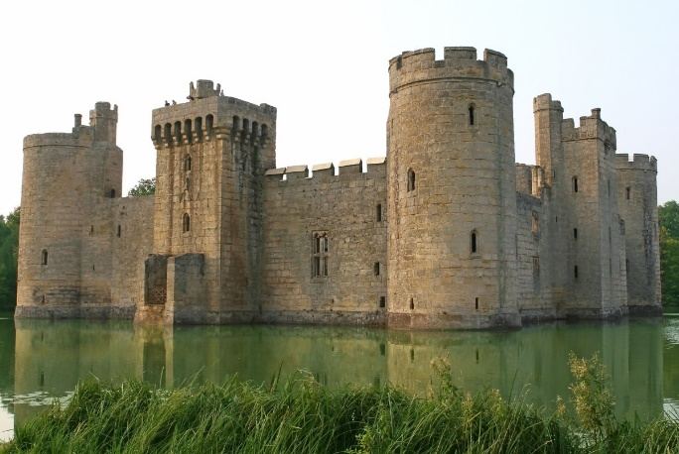anticipation of potential attacks, features have been included. In medieval construction, fortress features do differ to modern day techniques, but the concept behind them are the same.

Figure - Fortress example https://owlcation.com/humanities/What-Life-Was-Like-in-a-Medieval-Castle-Middle-Ages (Accessed: 8th November 2022 13:14)

This can be seen in the modern day when new buildings are built with state-of-the-art surveillance and security, new techniques, but a method that dates back hundreds of years. Some places however take a different approach. Whether the methods used are now out of date, or none were used in the first place, sometimes places and buildings need to update their fortress features due to more crime taking place. Somewhere once relatively safe may start seeing increased rate of crime – especially if their methods of defence have become out of date.

Mermaid Quay takes on both approaches. Opening in 1990 and seeing major regeneration since [8] this hypothesis states that crime in this area has increased. My following hypothesis state that fortification has taken place, and with this I am predicting that this is a result of increased or continued crime in the area. It has undergone regeneration and with this more security features have been introduced, and I want this hypothesis to uncover why this has happened.

### Evidence of major fortification of Mermaid Quay is present.

For Mermaid Quay to be considered a fortress landscape major fortification will need to have taken place. Features and development will need to be in this area in many forms, however, to maintain a friendly and welcoming feeling these features cannot be too prevalent or intrusive, or it may ward visitors off. The Big Brother concept is a synonym for abuse of government power, particularly in respect to civil liberties, often specifically related to mass surveillance and a lack of choice in society.[9] In essence it is the idea of constant surveillance by the government, with the idea of keeping people safe, but is taken too far and people begin to lose their sense of privacy.

Figure - CCTV Features in Mermaid Quay Joshua Netherton (20th October 2022)

One thing that developers need to be careful of when fortifying a landscape is taking their methods too far and creating this “Big Brother” feeling in a place. There is a fine line between monitoring somewhere to keep it safe, and intrusive surveillance that undoes the job it is trying to do. As seen in Figure 10, Mermaid Quay possesses CCTV throughout and has both public and private surveillance taking place. Bristol council will monitor Mermaid Quay, but also private businesses will monitor their own property and assets.

Having visited Mermaid Quay I don’t feel that the security measures in place where overbearing or intrusive, but it was clear there was surveillance taking place more so than other areas of Cardiff Bay. This hypothesis is that major fortification has taken place in this area, and using methods outlined in the next section I intend to prove that this is true, and that the methods are adequate for the needs of Mermaid Quay.

### Distribution of fortification is widely spread and even throughout Mermaid Quay.

When developing a place sometimes this development can be uneven and areas which get more funding may see further features implemented. This can happen for many reasons, but typically a divide in finances or funding can result in some areas getting better development than others. Typically, the crime rates reflect this as well. Tending to be higher in the areas with less funding, due to less policing and methods of mitigation.

Sometimes, this can occur with no issue, one place has more fortress development because it needs it, and somewhere else doesn’t have as much because it doesn’t need it. In this case, there is nothing bad about this. Adding CCTV – among other features – to somewhere that doesn’t need it can contribute to that “Big Brother” culture, and so it is best 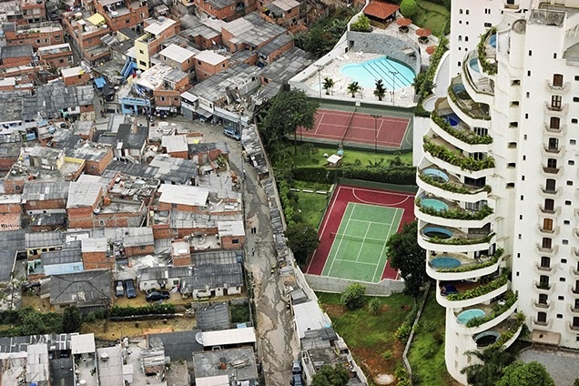to leave it.

As can be seen in Figure 11, São Paulo is an excellent example of how uneven development can occur on a large scale. Poverty right next to wealth with nothing more than a wall dividing them. This in itself can be considered a fortress landscape, the wealthier side, with a focus on making sure the residents are safe.

Figure - Uneven development in São Paulo https://www.architectural-review.com/essays/exhibitions/uneven-growth-tactical-urbanism-for-expanding-megacities (Accessed: 9th November 2022 11:06)

As development of Mermaid Quay has happened, it is clear that it has been relatively even throughout, and so I believe by extension the development of security features has been even too. It isn’t a large enough area for certain spots to be of a higher security than the rest of Mermaid Quay and any funding would be reserved for the entire area. The only exception I believe may occur is when private businesses implement their own security features for their businesses, this may result in shops being more heavily defended than the rest of the area. My research will prove than in general, the defences in place will be evenly spread and no one area will have been focused on more than the rest.

# Methodologies

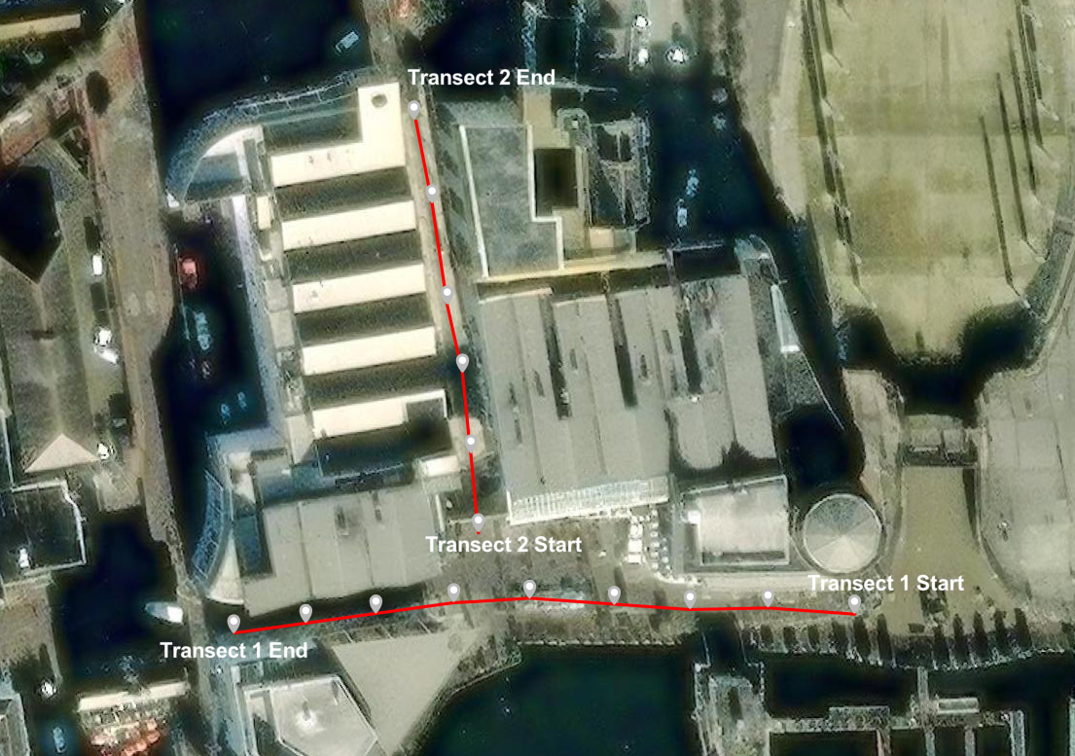 My data collection was done in the months of October and November 2022 in Mermaid Quay, Cardiff. To prove my hypothesis, I will complete two transects of the Quay, collecting data about security features I can see from points along my transect, one was completed on Thursday 20th October 2022 between 16:00 to 17:00, and one will be completed on Saturday 19th November 2022 between 14:00 and 15:00. I will also complete surveys, these will have no transect or order, I will randomly select people in the crowd, this will only be done on the 19th of November. To prove my hypothesis, I will also be using secondary data which I will collect online. I had tentatively planned on questioning someone on each point of my transect, but this glued me to one point, and it was easier to approach people wherever they were at the time. This method is a systematic approach.

Figure - Map of Transects https://www.arcgis.com/apps/mapviewer/index.html (Accessed: 15th November 2022 18:19)

Figure 13 is a map of the transects where I have counted the security features from. Each point is approximately 20 paces from each other, with one going East to West (9 points), and the other going South to North (6 points). It was from these points I had planned on doing my survey from too, but upon being there I decided against this idea due to difficulties with approaching people while remaining at that point, and instead randomly selected people in the area to question. This is a random sampling method.

For further data, I will also be using secondary data which I will access primarily through the internet.

## Risk Assessment

|  |  |  |  |
| --- | --- | --- | --- |
| Hazard? | Who is at risk? | Risk rating out of 5? (5 = High Risk) | What will be done? |
| Sunburn | Accomplices and I | 2 | Ensure suncream is applied if sunny, appropriate clothing is worn. |
| Trips and falls | Accomplices and I | 4 | Ensure appropriate footwear is worn. |
| Hit by car | Accomplices and I | 4 | Ensure road crossings are done at designated crossing points, and checks are made before stepping out. |
| Overly cold | Accomplices and I | 3 | Ensure appropriate clothing is worn. |
| Hostile/Aggressive Individuals | Accomplices and I | 2 | Ensure vigilance and appropriate judgement is used when approaching members of public. |
| Asthma | Myself | 2 | Ensure inhalers are brought with and readily accessible. |
| Unhygienic pavement hazards (Dog poo/sick) | Accomplices and I | 4 | Be vigilant when walking on pavement. |
| Hit by bike/e-scooters/other on pavement vehicles | Accomplices and I | 4 | Be vigilant when walking on pavement. |

Figure - Risk Assessment

## Crime in Mermaid Quay occurs prevalently

To decide whether crime in Mermaid Quay is prevalent, I will primarily be using secondary data. To answer this using primary, I would need to watch this area, for prolonged periods of time over multiple days, something I do not have the option of doing. There would be no way to accurately represent whether this is true using the two short days I will have spent in this area, as either one or both could easily be an anomaly, and I would not see much of the day – such as evening time – with the hours I am spending there.

As a result of this, I have elected to use secondary data to prove this hypothesis. Using Street Check [10], and CrimeRate [11] I will look at how much crime is currently taking place in this area. CrimeRate 12 is a fantastic online resource which allows me to look at a map with bars over each area of Cardiff, which tell me exactly what crime takes place there, and allows me to compare it to the rest of Cardiff. I will direct my attention to Mermaid Quay and look at what happens there, comparing this to surrounding areas to see if crime is frequent or not. One drawback of some online resources is it can be tricky to look at crime rates specifically in Mermaid Quay. This will provide some insight into my hypothesis, however, may leave some aspects of my response less specific than I had hoped.

Figure - CrimeRate map https://crimerate.co.uk/crime-map (Accessed: 16th November 2022 16:03)

For the Policing Website 11 I will not be able to look at Mermaid Quay specifically, as this website does not do a specific enough area for this to be possible. In which case I will look at either Cardiff or Cardiff Bay as a whole.

Once I have this information, I will lay it out in the form of pie charts, with each section containing a different type of crime which has taken place, and once I am able to show how much crime is taking place, this will tell me whether crime is or is not prevalent in Mermaid Quay. This method is best as it shows a very clear comparison of the proportion of different crimes and their severity in one area.

Along with this, I will be using some primary data in the form of surveys from 14:00 to 15:00 on Thursday 20th November 2022. This will be done in the vicinity of Point 3, Point 6, and Point 9 along Transect 1 and Point 1, Point 3, and Point 5 along Transect 2, in Figure 15 at the top of my Methodologies section. I will use a random sampling method to select the people I ask in Mermaid Quay, which is the best way to gather a wide range of unbiased results. I will be asking them to use one word to describe Mermaid Quay, and then presenting the results in a word map. In the second part I will give them a list of words, Mad, Scared, Joyful, Powerful, Peaceful, Sad, and ask the person to choose which one relates most to how they feel when in Mermaid Quay. I will then produce an emotion map of the area. Using these two methods, I can see if how people feel about the area reflects crime statistics and the conclusions, I have drawn from the data I gather. A word map will give a very obvious depiction of what people felt the most here. I have chosen the emotion map for a similar reason, as it will show clearly where abouts people feel different emotions in the Quay. Depending on the results from this, if many feel unsafe and sad, then it is clear that crime is prevalent here, should the opposite be the result, then I can conclude that based on people’s opinions, crime is not prevalent. I will then compare the results of my primary and secondary data.

Some members of the public may not want to share their opinion of Mermaid Quay and could consider my questions to be invasive or offensive. To mitigate this, I will explain to each interviewee that the survey is not compulsory, and all questions are designed to have a range of potential answers, to gain a truthful response and avoid bias, not because one answer is correct. I also want to ensure I get a range of ages and responses from people both local to Mermaid Quay/Cardiff Bay, and people further afield. I will have an age range section and a living location section on my survey, and I will ensure that I get a varied group of respondents. Should I have collected data for all age groups except one, I will only ask people to continue with the survey if they fit into that age section, this provides a stratified sampling approach to my data collection and once I adopt this method and choose people when I see them, this will also be an opportunistic sampling approach. This method of sampling provides me with a very varied range of results providing me with the best data to use.

## Evidence of major fortification of Mermaid Quay is present

To decide whether Mermaid Quay is a fortress landscape there is a requirement that fortification is in place in Mermaid Quay. To gather immediate data, I will be using exclusively primary data in the form of transect tally counts. However, to prove this hypothesis I will be using a combination of primary and secondary data. It is said “CCTV can act as a hug deterrent to criminals, especially when it comes to pre-planned crimes.” [12] Along my transects, Transect 1 and Transect 2 in Figure 13, from my start point I will walk 20 paces, and then stop. From this point I will count all surrounding CCTV, only including cameras within close proximity – if I can see one but it is across the Quay, I will not count it until I am closer. I will then mark on a map where each of these cameras are and display this in my data representation section.

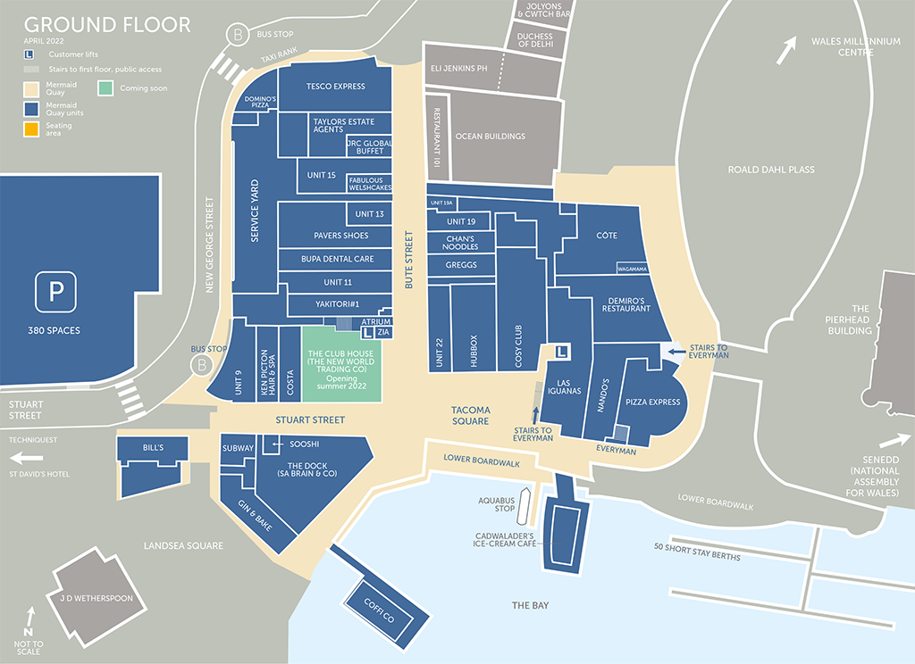 There is little way of speeding this up, as a lot of my own judgement is used. Twenty paces will differ from person to person, along with what cameras are considered close enough to the stopping point for that section, so repeated examples of this data collection by different people may yield different points. My method is a systematic sampling method, with the start points selected as the far right of Mermaid Quay and the most southern point of Bute Street, as seen in Figure 13. I have chosen to do it like this as it allows me to cover the entire Quay in a logical way, meaning I can confidently say I did not forget to look at a section or miss anything I am looking for, or accidentally count features twice unknowingly. Overall, there are 15 stop points, with 9 on Transect 1, and 6 on Transect 2.

Figure - Shop map of Mermaid Quay https://www.mermaidquay.co.uk/leasing-opportunities/ (Accessed: 17th November 2022 12:01)

Another limitation is that while going along my transects it is possible I will miss features not visible from my transect points, should they be tucked around obstacles or around corners I do not go down. This means no matter my confidence my results will be an average, however, I have selected my transects to cover the vast majority of key areas in Mermaid Quay so that any missed features are negligible.

While completing these transects, I will also be counting any alarm systems I can see attached to buildings. I expect to see at least one per business. As I go along my transects, I will take both a tally of what I can see, along with marking each type onto a map I have in paper in front of me to note location (Figure 17).

Following this I will replicate this map digitally and represent my counts of security features in bar charts. If I see any other features while completing my transects, I will mark these down and add them in respectively. I expect to see police officers on patrol while completing my data collection, which I will mark down as a security feature too. For this hypothesis I will also be using annotated pictures to describe the location and what security features are present. These methods are an excellent way of showing the ratio of security features relative to each other and where in the Quay they are located.

I will do this on both visit dates, Thursday 20th of October 2022 between the hours of 16:00 and 17:00 and on Saturday 19th November 2022 between the hours of 14:00 and 15:00.

Once I have this data, I will be able to look at how much security there is throughout Mermaid Quay and use my judgement to decide whether this constitutes as a Fortress Landscape based on comparisons against other facilities already deemed a fortress landscape that I will look at online.

## Distribution of fortification is widely spread and even throughout Mermaid Quay

Landscape means “all the visible features of an area of land” [13] In the context of my research this means the entire area I am looking at. When deciding whether Mermaid Quay is a fortress landscape or not, it is crucial that the points I use to argue either way are prevalent throughout the entire Quay, not just a small area or section of. To do this I will be using three data collection techniques, a heat map, land use survey, and looking at land value.

My heat map will use the data collected during my transect tally, however, I will represent the data instead by grouping everything I find into “Security Features” collected on the 19th of November between 14:00 and 15:00. Then, overlaying a map of Mermaid Quay, depending on how many “Security Features” are in an approximately 8mx8m section of the Quay, the square will be given a colour, with different colours representing different amounts of features. This will cover the entire Quay and for this hypothesis to be true generally there should only be one colour throughout representing fortification all over the Quay, providing a very easy to read display of which areas have what. This provides a general overview that needs little interpretation other than referencing they key on the map, compared to bar graphs or spider diagrams. While these could be used, they are more complicated and need to be read into much more than a coloured overlay on a map. One issue with this method is I will only be able to cover the outdoor sections of the Quay where I walked, and inside of buildings or sections of the Quay I was unable to visit cannot be shown. I will represent these areas differently to areas I looked at containing no features, to make it clear what was present and where.

I completed a land use survey of Mermaid Quay (see Figures 6 and 17) the Quay on the 20th of October 2022, which is a systematic sampling survey. This was done as it was the most logical way of ensuring all buildings are looked at and included in the survey along with this being the present manner to collect this data, having been on an A-Level Geography trip at the time. This will allow me to look at what areas of Mermaid Quay are being used for what. With this, I can compare it to the heat map and say what the land where high levels of security are present are being used for. I will then use secondary data to look at land value around Mermaid Quay. Finally, I will bring all three of these together and look at what the distribution of fortification is, what land is being used for where security is high, and whether value is high or low in these areas to prove the hypothesis that distribution is even throughout the Quay.

# Data Representation and Analysis

# Table of Figures

Figure 1 - Map of Mermaid Quay https://www.google.co.uk/maps/place/Mermaid+Quay,+Cardiff/@51.4635816,-3.1680653,534m/data=!3m2!1e3!4b1!4m5!3m4!1s0x486e0337c76d4031:0xf94e95c4c6431b7a!8m2!3d51.4635816!4d-3.1658766 (Accessed: 1st November 2022 10:11) 0

Figure 2 - Sky view of fortress https://www.atlasobscura.com/places/fortress-of-almeida (Accessed: 1st November 10:01) 2

Figure 3 - Anti-homeless architecture https://www.theguardian.com/society/2015/feb/18/defensive-architecture-keeps-poverty-undeen-and-makes-us-more-hostile (Accessed: 3rd November 2022 10:52) 3

Figure 4 - Anti-homeless architecture in Mermaid Quay Joshua Netherton (20th October 2022) 3

Figure 5 - Highlight of Mermaid Quay https://www.google.co.uk/maps/place/Mermaid+Quay,+Cardiff/@51.4640905,-3.168601,16.11z/data=!4m5!3m4!1s0x486e0337c76d4031:0xf94e95c4c6431b7a!8m2!3d51.4635816!4d-3.1658766 (Accessed: 4th November 2022 11:04) 4

Figure 6 - Map of Cardiff https://www.google.co.uk/maps/@51.4819126,-3.1767277,13z (Accessed: 4th November 2022 11:04) 4

Figure 7 - Map of United Kingdom https://www.google.co.uk/maps/@54.4861569,-7.1862054,6z (Accessed: 4th November 2022 11:15) 4

Figure 8 - Place map for Cardiff https://www.google.co.uk/maps/place/Cardiff/@51.5517743,-3.7323955,9z/data=!4m5!3m4!1s0x486e02d434ec53f5:0x143406db6586670e!8m2!3d51.483707!4d-3.1680962 (Accessed: 4th November 2022 12:46) 5

Figure 9 - Cardiff Bay https://walesguidebook.com/things-to-do/south-wales/cardiff/cardiff-bay/ (Accessed: 11th November 2022 11:50) 5

Figure 10 - Fortress example https://owlcation.com/humanities/What-Life-Was-Like-in-a-Medieval-Castle-Middle-Ages (Accessed: 8th November 2022 13:14) 6

Figure 11 - CCTV Features in Mermaid Quay Joshua Netherton (20th October 2022) 6

Figure 12 - Uneven development in São Paulo https://www.architectural-review.com/essays/exhibitions/uneven-growth-tactical-urbanism-for-expanding-megacities (Accessed: 9th November 2022 11:06) 7

Figure 13 - Map of Transects https://www.arcgis.com/apps/mapviewer/index.html (Accessed: 15th November 2022 18:19) 8

Figure 14 - Risk Assessment 9

Figure 15 - CrimeRate map https://crimerate.co.uk/crime-map (Accessed: 16th November 2022 16:03) 9

Figure 17 - Shop map of Mermaid Quay https://www.mermaidquay.co.uk/leasing-opportunities/ (Accessed: 17th November 2022 12:01) 11

# Bibliography

1. https://www.coolgeography.co.uk/advanced/New_urban_landscapes.php#:~:text=Fortress%20landscapes&text=Developments%20are%20deliberately%20landscaped%20and,between%20different%20groups%20of%20people. (Accessed: 3rd November 2022 10:20)
2. https://www.bigissue.com/news/housing/anti-homeless-architecture-hostile-designs/#:~:text=There%20are%20many%20names%20for,in%20a%20town%20or%20city. (Accessed: 3rd November 2022 10:53)
3. https://www.coolgeography.co.uk/advanced/New_urban_landscapes.php#:~:text=Fortress%20landscapes&text=Developments%20are%20deliberately%20landscaped%20and,between%20different%20groups%20of%20people. (Accessed: 3rd November 2022 14:47)
4. https://www.cityevolutions.org.uk/wp-content/uploads/171127-Working-Paper-7-Bristol-Case-Study-Report.pdf (Accessed: 4th November 2022 11:10)
5. https://www.walesonline.co.uk/business/business-news/grand-promises-cardiff-bay-success-14070156#:~:text=That%20name%20is%20a%20legacy,into%20the%20city's%20moribund%20docklands. (Accessed: 4th November 2022 12:34)
6. https://www.oxfordlearnersdictionaries.com/definition/english/urban-development-corporation (Accessed: 11th November 2022 11:49)
7. http://calmview.cardiff.gov.uk/Record.aspx?src=CalmView.Catalog&id=DCBDC#:~:text=CBDC%20was%20an%20organisation%20established,local%20authorities%20and%20private%20companies.
8. https://www.mermaidquay.co.uk/history-of-mermaid-quay/ (Accessed: 8th November 2022 13:22)
9. Strouf, J. L. H. (2009) The Literature Teacher’s Book of Lists. 2nd edn. London: Jossey-Bass. (Accessed: 9th November 2022 11:24)
10. https://www.streetcheck.co.uk/crime/cf105bz (Accessed: 16th November 2022 15:44)
11. https://crimerate.co.uk/south-glamorgan/cardiff (Accessed: 16th November 2022 15:45)
12. https://www.caughtoncamera.net/news/5-benefits-installing-cctv-home/#:~:text=Visual%20crime%20deterrent,the%20safety%20of%20your%20family. (Accessed: 17th November 2022 11:43)
13. https://en.wikipedia.org/wiki/Landscape (Accessed: 17th November 2022 12:25)